Inventory product management
Ideation Phase
Brainstorm & Idea Prioritization

Date | 07/03/26
Team ID | SWTID-2026-5992
Project Name | Product Inventory Management System
Maximum Marks | 4 Marks

Brainstorm & Idea Prioritization
The team identified a common real-world problem related to inefficient product inventory management in small and medium businesses. Many organizations still rely on manual records or basic spreadsheets, which often lead to issues such as inaccurate stock tracking, delayed updates, and difficulty in generating reports.
Brainstorming Process
During the ideation phase, team members conducted brainstorming sessions to explore different web-based solutions. Each member proposed ideas that could improve the efficiency, reliability, and accessibility of inventory management systems.

Evaluation Criteria
Each idea was evaluated based on the following criteria:
Criteria | Description
Feasibility | Ease of development within the project timeframe
Scalability | Ability to expand with more products and users
Security | Protection of inventory data and user authentication
Learning Outcome | Opportunity to apply and improve MERN stack skills

Technology Consideration
The system will be developed using the MERN Stack, which includes:
- MongoDB for database management
- Express.js for backend API development
- React.js for building the user interface
- Node.js for server-side functionality

Team Gathering, Collaboration and Selection of the Problem Statement
Team Formation
The project team was formed by bringing together members with a shared interest in developing a practical web-based solution using the MERN stack. Each team member contributed their skills and ideas to ensure effective collaboration throughout the project.
Team Collaboration
The team conducted several discussions and meetings to identify real-world problems that could be solved using web technologies. During these collaborative sessions, members shared their observations and experiences related to common challenges faced by businesses in managing product inventories.

Identification of Possible Problems
During the discussions, several potential problem areas were identified, such as:
- Difficulty in tracking product stock manually.
- Lack of real-time inventory updates.
- Errors caused by manual record keeping.
- Limited accessibility of inventory data.

Selected Problem
This problem was chosen because:
- It is a common real-world issue faced by many businesses.
- A digital system can significantly improve efficiency and accuracy.
- It provides an opportunity to apply full-stack development skills using the MERN stack.

Problem Statement
The selected problem statement for the project is:
“To design and develop a web-based Inventory Management System using the MERN stack that allows businesses to efficiently manage product inventory, track stock levels, and improve accuracy in inventory operations.”

Brainstorm, Idea Listing and Grouping
During the brainstorming phase, all team members were encouraged to share their ideas freely without any restrictions. This open discussion allowed the team to explore multiple perspectives and potential solutions for the identified problem. Each idea was noted and later analyzed to determine its relevance to the project goals.After collecting all ideas, they were organized and grouped into meaningful categories to simplify evaluation and decision-making.

Idea Categories
Category | Description | Example Ideas
Inventory Management Features | Core functions required to manage product stock effectively. | Add/Edit/Delete products, stock tracking, product categories
Automation Features | Functions that help reduce manual work and improve efficiency. | Low stock alerts, automatic stock updates, notification system
User Management | Features related to access control and user roles. | Admin login, role-based access, staff accounts
Reporting and Analytics | Tools that help users understand inventory performance. | Sales reports, stock summary, dashboard charts

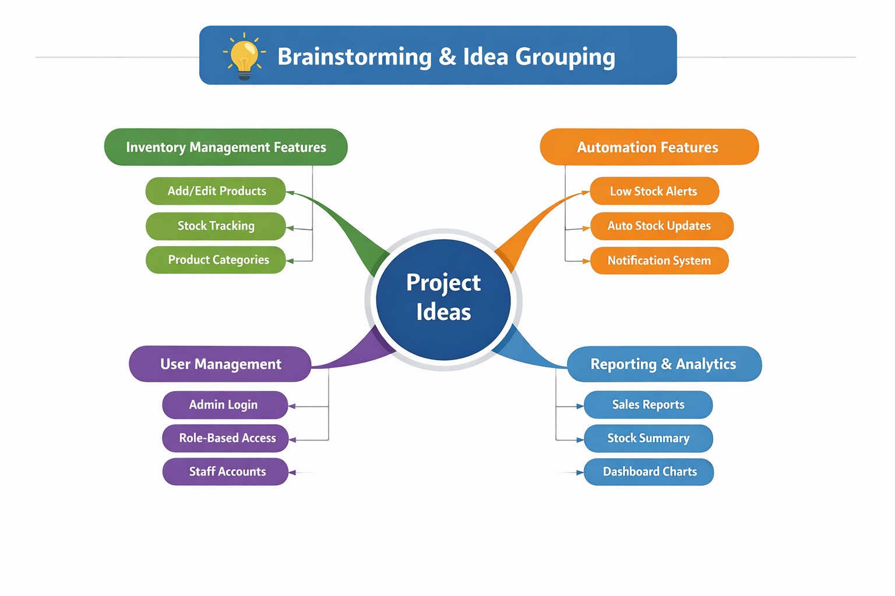
Idea Prioritization

Priority Levels
Priority | Focus | Example Ideas / Features
High Priority (Implemented Features) | Core functionalities essential for project completion | JWT Authentication (Register/Login), Private Product CRUD Operations, MongoDB Database Integration, Secure API Routes, Search Functionality
Medium Priority (Enhancements) | Features that improve usability and polish | Product Filtering, Improved UI Components, Error Handling Improvements
Low Priority / Future Scope | Advanced features for future expansion | Role-Based Admin System, Analytics Dashboard, Notifications for Low Stock, Deployment & Cloud Hosting
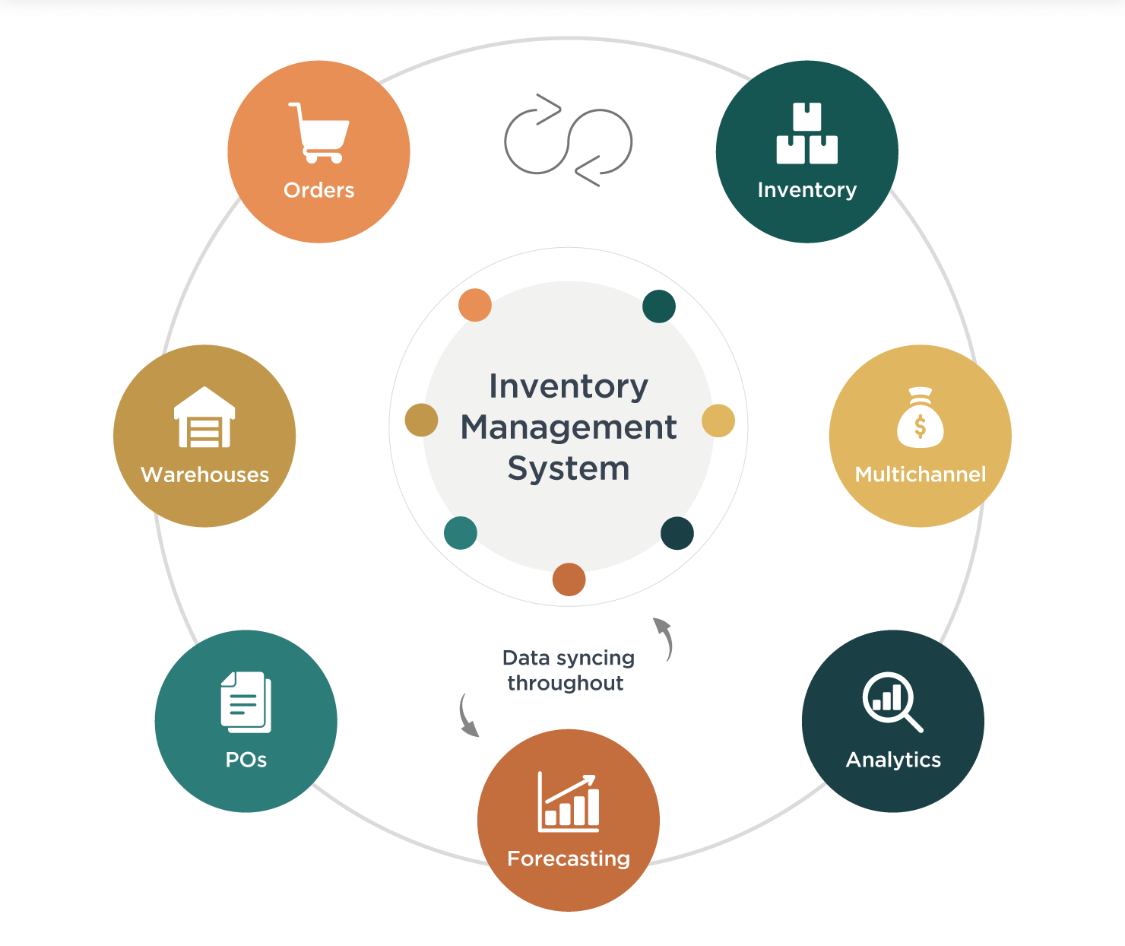

Final Decision
The team finalized the Product Inventory Management System as the project focus. This choice maximizes learning opportunities in:
- Authentication systems
- Backend API design
- Frontend integration using MERN stack technologies
